Brock media for S. acidocaldarius

Corresponding author: Fredrik Hurtig
List of authors: Fredrik Hurtig, Gabriel Tarrason Risa and Buzz Baum
Group leader: Buzz Baum
Institution: MRC Laboratory for Molecular Cell Biology

Zenodo DOI: [To be added after scientific review by the Society for Archaeal Biology]

Protocol Category: Cell Biology
Model organism(s): Sulfolobus acidocaldarius
Tags: Growth media, glycerol stock

Abstract
This protocol describes how to prepare Brock growth media, and how to create glycerol stocks, for Sulfolobus acidocaldarius.

Related publication: Brock et al. 1972

Background
S. acidocaldarius belongs to the TACK superphylum (Guy and Ettema, 2011). At the time of writing, these archaea are the closest archaeal relatives of eukaryotes that can be easily grown and studied in a lab. As such, there is considerable interest in understanding their cell biology. S. acidocaldarius is also one of the most well established model systems for studying hyperthermophiles.
The growth medium is based on the first account of growing conditions for Sulfolobus by Brock and colleagues (Brock et al. 1972). It should be prepared fresh with dd water the same day you do the experiment, and adjusted to pH 2.9 with 1:1 sulfuric acid. However, Brock stock solutions can be stored after sterilisation at room temperature. The ferric solution should be protected from light to prevent chemical precipitation.

Materials
Stock solutions
- Brock I (1L, 100x)
  - 7 g CaCl₂ x 2H₂O
  - Autoclave
- Brock II+III (1L, 100x)
  - 130 g (NH₄)₂SO₄
  - 25 g MgSO₄ x 7H₂O
  - 28 g KH₂PO₄
  - 50 ml trace element solution (from a 2000x TES)
  - 1.5 ml 1:1 H₂SO₄
  - Autoclave
- Fe-solution (1L, 100x)
  - 2 g FeCl₃.6H₂O
  - Filter-sterilise
- NZ-amine solution (1L, 10%, 100x)
  - 100 g NZ-Amine (Brand of NZ-Amine is important, we use Sigma-Aldrich 82524)
  - Autoclave
- Trace element solution (1L, 2000x)
  - 9.0 g Na₂B₄O₇.10H₂O (Insoluble at neutral pH, add 1:1 H₂SO₄ until it dissolves. May take several mL, however end pH is unimportant.
  - 0.44 g ZnSO₄.7H₂O
  - 0.1 g CuCl₂.2H₂O
  - 0.06 g NaMoO₄.2H₂O
  - 0.06 g VOSO₄.2H₂O
  - 0.02 g CoSO₄.7H₂O (MW 281) (alternatively use CoCl₂.6H₂O, MW 237)
  - 3.6 g MnCl₂.4H₂O
- 1:1 H₂SO₄ (100 mL)
  - 50 ml 95-98% H₂SO₄
  - Slowly add H₂SO₄ to 50 ml dd H₂O. The solution can become extremely hot and may need cooling!

Brock media preparation
 | For 1 L | For 250 mL | For 50 mL
Brock I | 10 mL | 2.5 mL | 500 uL
Brock II + III | 10 mL | 2.5 mL | 500 uL
Fe solution | 10 mL | 2.5 mL | 500 uL
Sucrose 20% | 10 mL | 2.5 mL | 500 uL
NZ-amine (10%) | 10 mL | 2.5 mL | 500 uL
1:1 H₂SO₄ | 200 uL | 50 uL | 10 uL

Protocol
- To start a new culture, take a small amount of frozen glycerol stock on a yellow pipette tip, and place the tip in ~20 ml room temperature Brock media, and grow at 75-80°C with rotation
  - Culture normally reaches exponential phase in 24-48 hours
  - Use aluminium foil to seal the opening of the flask tightly to prevent evaporation. A failure to do this can easily evaporate a culture overnight
- Subsequent dilutions are needed every 24 hours
  - Dilutions should be done using pre-heated Brock media

Glycerol stocks
- Grow cell to late exponential phase (OD 0.5-0.8, optional)
- Centrifuge 10 ml of culture in a 15 ml falcon tube for 5 min at approximately 4000 RCF
- Remove 9 ml of supernatant and resuspend the pellet in the remaining media. Add up to 1 ml of 100% glycerol and mix thoroughly.
- Store at –80°C immediately.
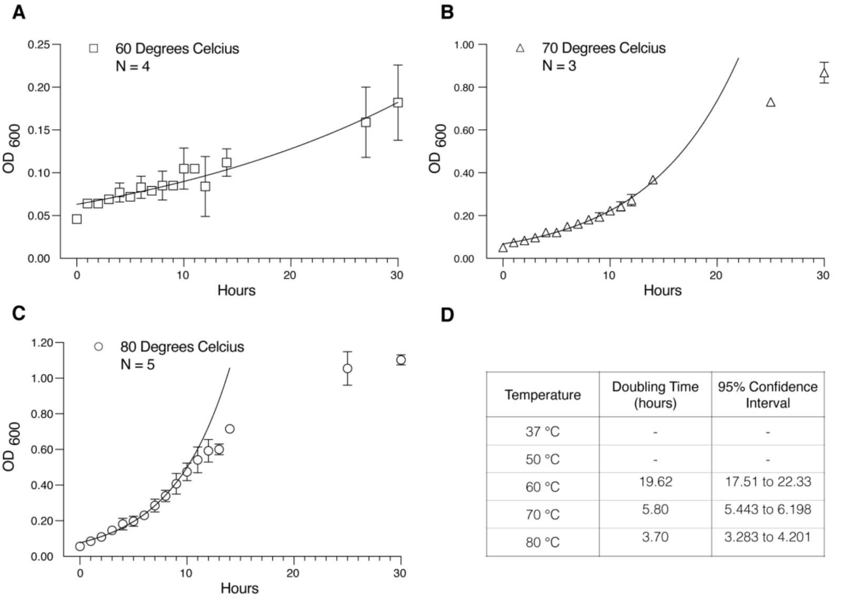
Figure 1. Growth curves of S. acidocaldarius at various temperatures. Reprinted with permission (Tarrason Risa, 2021).

Additional notes
Brock media pH will increase significantly during growth if not enough acid has been added. In our experience pH 2.9 is usually sufficient for a stable pH during growth

Competing interests
The authors declare that they have no conflict of interest.

Acknowledgments
We thank the entire Baum lab for their input; the Albers and Lindås lab for advice and reagents, with special thanks to M. Van Wolferen, S. Albers, and Mohea Couturier.

References
- Brock, Thomas D. et al. (1972). \Sulfolobus: A new genus of sulfur-oxidizing bacteria living at low pH and high temperature". In: Archiv für Mikrobiologie 84.1, pp. 54{68. issn: 0003-9276. doi: 10.1007/bf00408082.
- Tarrason Risa, Gabriel; (2021) Archaeal roots of eukaryotic cell cycle control and ESCRT-III mediated cell division. Doctoral thesis (Ph.D), UCL (University College London). URI: https://discovery.ucl.ac.uk/id/eprint/10132115

